

American International University-Bangladesh (AIUB)  
**Department of Computer Science  
Faculty of Science & Technology (FST)**

**Investor Finder**

A Software Requirement Engineering Project Submitted

By

|  |  |  |  |  |
| --- | --- | --- | --- | --- |
| **Semester: Spring_22_23** | | **Section:** | **Group Number:** | |
| SN | Student Name | Student ID | Contribution (CO1+CO2) | Individual Marks |
| 06 | Rafid Redwan Khan | 20-42239-1 |  |  |
| 26 | MD. Sadi Al Huda | 20-43129-1 |  |  |
| 28 | Mustafa Wasif | 20-43175-1 |  |  |
| 38 | Khondokar Abdul Aziz | 20-43638-2 |  |  |
|  |  |  |  |  |

The project will be Evaluated for the following Course Outcomes

|  |  |  |
| --- | --- | --- |
| Evaluation Criteria | Total Marks (50) | |
|  | |
| Introduction, Format, Submission, Defense | [10 Marks] |  |
| System Overall Description & Functional Requirements | [10 Marks] |  |
| System Quality Attributes and Project Requirements | [10 Marks] |  |
| UML and E-R Diagram with Data Dictionary | [10 Marks] |  |
| UI/UX Prototyping | [10 Marks] |  |

Software Requirements Specification

for

Investor Finder

Version 2.0 approved

Prepared by  
Rafid Redwan Khan  
MD. Sadi Al Huda  
Mustafa Wasif  
Khondokar Abdul Aziz

American International University-Bangladesh

28/04/2023

Table of Contents

Revision History 3

1. Introduction 4

1.1 Purpose 4

1.2 Document Conventions 4

1.3 Intended Audience and Reading Suggestions 4

1.4 References 5

2. Overall Description 5

2.1 Product Perspective (Business Requirements) 5

2.2 Product Functions 5

2.3 User Classes and Characteristics 6

2.4 Operating Environment 6

2.5 Design and Implementation Constraints 6

2.6 User Documentation 6

3. System Requirements 7

3.1 System Features 7

3.2 Non-Functional/Quality Requirements 10

3.3 Project Requirements 11

4. Interface Requirements 12

4.1 UML 12

4.2 Data Dictionary 14

4.3 UI/UX Design Specification 15

# Revision History

|  |  |  |  |
| --- | --- | --- | --- |
| **Name** | **Date** | **Reason for Changes** | **Version** |
| Rafid Redwan Khan | 11/04/23 | Purpose was wrong | 1 |
| Md Sadi Al Huda | 18/04/23 | Changing requirement cross-reference | 2 |

# Introduction

## Purpose

A software system's features, capabilities, and restrictions, as well as their functional and non-functional requirements, are all explicitly defined and documented in an SRS document. The SRS document acts as a roadmap for the software development process and aids in making sure that the finished product complies with stakeholders' needs. In this document we are going to describe the Investor Finder system.

A tool used by business owners or organizations looking for money to draw in potential investors is an Investor Finder system. An Investor Finder document's goal is to give a succinct and persuasive overview of the company opportunity, stressing the salient features that would attract possible investors.

## Document Conventions

Each of the requirements has a distinct identification number, which is made up of a series of letters and a number, such as QA1. When the requirement is formed, these numbers are given. When sections or requirements are added to or removed from this document, the requirement numbers must remain static and unaltered. Additionally, a unique title is given (such as System Features or Non-functional Requirements) to each requirement so that it can be found in the table of contents. (UCAR, 1990)

In this document every requirement has their own priority level, pre-condition and cross reference. For ease of readability, we have highlighted the heading and key points. Besides that, we have used numerical points to separate individual parts of this document.

## Intended Audience and Reading Suggestions

Potential investors who are interested in funding start-ups or new enterprises would be the target audience for an investor finding system paper. A clear and succinct summary of the investment opportunity, the company model, market potential, competitive advantages, financial projections, and finance requirements should be included in the paper, which should be tailored to their needs and interests. The paper should also emphasize the accomplishments made by the company thus far, the credentials and expertise of the management team.

For the readers, this document started with a title and table of contents. After that, in the introduction part a reader of this document will find what to expect from this document, who are the intended audiences and where are the contents taken from. Later on, the document he/she will find about the product and who will use this product. Moreover, how the system was designed and implemented will also be found in this document.

Lastly, the reader will learn about how the system works through the UML diagram which is a graphical view of the system shown in a standardized way. Before using the system, readers will know how the system looks with UI/UX design.

## References

1. Eko H., Isnanto R. R., Mikhail A. S. SRS Document Proposal Analysis on the Design of Management Information Systems According to IEEE STD 830-1998. The 3rd International Conference on e-Learning (ICEL 2011).

2. University Corporation for Atmospheric Research (UCAR). Document Conventions. Website: https://www2.cgd.ucar.edu/cseg/reqdoc_template/cmp_reqdoc/node4.html

# Overall Description

## Product Perspective

The software for an investor finder should be designed to help entrepreneurs and businesses easily find and connect with potential investors. The software should provide features such as search filter, investor profile, communication tracking tools, and analytics to help users make informed decisions.

Business Requirement:

The business requirement for an investor finder software may include.

1. Revenue Model: There should be a defined business model for the software, such as subscription fees, a commission on a successful investment round, or advertising money.

2. Target Market: A specific target market, such as startups, small businesses, or enterprises, should be taken into account when developing the program.

3. Integration: The software should be able to integrate with other business tools such as CRM software, email marketing, and financial analysis tools.

4. Security: The software should have robust security features to protect sensitive information such as investor profiles and financial data.

5. User Experience: the software should be user-friendly, intuitive, and easy to navigate, with clear instructions and minimal training required.

6. Scalability: The software should be designed to scale as the user base grows, with the ability to handle a large volume of data and search queries.

7. Technical requirements: The software should be built using modern and scalable technologies, with a strong focus on performance, reliability, and maintainability.

Overall, the business requirement for an investor finder software should be designed to support the growth and success of its end-users, while also generating revenue for the software provider.

## Product Functions

A system that aids users in locating possible investors for their ventures or projects is required software for the investor finder. Users can provide information about their projects or businesses, including their industry, financial requirements, and location.

Once this information has been matched with potential investors in the database, the system displays a list of such investors to users. Users of the software can also filter the results depending on a number of factors, including the type of investor, the size of the investment, and the stage of the investment.

The software might additionally contain tools that let users interact with potential funders, monitor their progress, and control their fundraising activities, in addition to these functionalities. The system's overall goal is to make discovering and connecting easier.

## User Classes and Characteristics

Startups, businesses, and entrepreneurs who want to raise funds through investments frequently use investor finder software. The software can also be used by investors themselves to locate potential investment possibilities that meet their investment criteria, such as venture capitalists or angel investors.

Typically, you would enter numerous parameters that are significant to you at the outset of using investor discovery software. These standards might cover factors including investment size, sector, location, and stage. The software will compile a list of potential investors or investment opportunities based on your inputs that meet your criteria.

Following that, you may check each investor's investment portfolio, conduct a more thorough investigation into each possibility, and gather contact information to get in touch with them. some investor finding tools.

## Operating Environment

There are multiple platform systems that could work such as android, iOS, windows etc. Our platform will work on a web-based windows platform. From a hardware perspective our software will work on a personal computer.

## Design and Implementation Constraints

* Although there are multiple design applications, we used only Canva to design our system interface. But in real life developers have to implement these features through web technology. So, it might be quite difficult to replicate like the system interface we have shown. Moreover, there might be hardware restrictions and not enough memory to build this system reliably.
* We recommend developers to use languages like HTML, Php, JavaScript etc. and for security purpose they must use validation features.

## User Documentation

* New users can sign up for the system using their email address or phone number, password, and NID. Users must include a valid phone number or email address.
* Users must be able to log in to the software using their assigned username and password. The login information (username and password) will be compared to database records for verification. If the login process is successful, the user account's home page will be shown.
* Users have access to posts with investigation findings. The 'Show more' option allows users to access the whole post details.
* Users can report a post as inappropriate by using the three-dot menu on the top-right corner.
* By selecting the "Deal" button from the post, a user can send a deal request for investing to an investment post. Owners of investment posts will be alerted and required to accept or decline transaction requests.
* Users can view & edit profile information from Profile page. Users also can previously post and deal with information from their profile.
* If the user receives a message or receives an investment related to requests, a notification will be delivered.

# System Requirements

## System Features

**3.1.1 User Registration**Functional Requirements

3.1.1.1 The system will allow new user to register into the system using Email address or

Phone number, Password, NID.

3.1.1.2 Users must use a valid Email address or Phone Number.

3.1.1.3 Users’ Email or Phone number will be verified by using OTP.

3.1.1.4 Password must be followed proper pattern.5

**Priority Level:** High

**Precondition:** User must have valid Email address or Phone Number and NID.

**Cross-references:** N/A

**3.1.2 User Sign in**

Functional Requirements

3.1.2.1 Registered user can sign in to the system using Email address or Phone number and

Password.

3.1.2.2 User can recover forgotten password using providing a valid OTP sent into their

Email address or Phone Number.

**Priority Level:** High

**Precondition:** User must have registered into the system.

**Cross-references:** 3.1.1

**3.1.3 Browse Post**

Functional Requirements

3.1.3.1 User can view investigation finding posts.

3.1.3.2 By clicking the ‘Show more’ button users can view full post details.

**Priority Level:** Low

**Precondition:** User must be signed into the system.

**Cross-references:** 3.1.2

**3.1.4 Report Post**

Functional Requirements

3.1.4.1 Users can report a post as inappropriate by using the three-dot menu on the top-right corner.

**Priority Level:** Medium

**Precondition:** User must be signed in to the system.

**Cross-references:** 3.1.2, 3.1.5

**3.1.5 Post for Investment**

Functional Requirements

3.1.5.1 User can post with required investment details and amount.

3.1.5.2 User can update or delete post from profile section that contains posted investment

posts.

**Priority Level:** High

**Precondition:** User must be signed in to the system.

**Cross-references:** 3.1.2

**3.1.6 Investment Dealing**

Functional Requirements

3.1.6.1 User can send a deal request for investing to an investment post by clicking ‘Deal’

button from post.

3.1.6.2 Investment post owners will be notified and have to confirm or reject deal requests.

Dealing requests will remain pending if the post owner does not accept or reject the post.

3.1.6.3 Post owner and investor also can contact each other through a messaging system.

3.1.6.4 Multiple deal requests can be set for individual investment posts.

3.1.6.5 Users can rate each other after deal confirmation.6

**Priority Level:** High

**Precondition:** User must be signed in to the system.

**Cross-references:** 3.1.2, 3.1.5, 3.1.7

**3.1.7 User Profile**

Functional Requirements

3.1.7.1 User can view & edit profile information from Profile page.

3.1.7.2 User also can previously post and dealing information from profile.

**Priority Level:** Medium

**Precondition:** User must be signed in to the system.

**Cross-references:** 3.1.2,

**3.1.8 User Report**

Functional Requirements

3.1.8.1 Users can report each other from their user profile with a message.

**Priority Level:** Low

**Precondition:** User must be signed in to the system.

**Cross-references:** 3.1.2, 3.1.7

**3.1.9 Notification**

Functional Requirements

3.1.9.1 Notification will be sent if user receive any message or he/she get any investment dealing with requests.

3.1.9.2 User will also be notified if he/she gets any warning from the admin.

**Priority Level:** Medium

**Precondition:** User must be signed in to the system.

**Cross-references:** 3.1.2, 3.1.6

**3.1.10 Feedback**

Functional Requirements

3.1.10.1 System visitors can send feedback and opinions about the system.

**Priority Level:** Medium

**Cross-references:** 3.1.2, 3.1.7

## Non-Functional/Quality Requirements

**QA1: Usability:** The attribute usability means the ease with which each user can use the system to accomplish certain tasks. The system is designed in such a way that users will easily understand how to use the system. Users can easily post for investment and deal for investment from the system. The features are simply designed and developed so that users can easily understand them by seeing them.

**Priority Level:** Medium

**Precondition:** N/A

**Cross-references:** QA3, QA5

**QA2: Security:** This attribute enables the system to control unauthorized persons to access the system. Users who have a valid email address or phone number and passwords can only sign into the system. This attribute is important since security denotes the ability of the system to protect the data from unauthorized persons.

**Priority Level:** High

**Precondition:** N/A

**Cross-references:** QA6

**QA3: Reliability:** These attributes are defined as how a system is expected to perform its intended functions with required precession. The system will be implemented in such a way that users get their intended function like when they want to view investment posts, they can see them. No error gets generated. It ensures that the user gets the correct output. Besides, the system also doesn’t take much time to respond to users’ actions.

**Priority Level:** Medium

**Precondition:** N/A

**Cross-references:** QA2, QA6

**QA4: Flexibility:** The system is flexible enough to modify. It is adaptable to other functionalities and easy to add code to the system and upgradation for new features.

**Priority Level:** Medium

**Precondition:** N/A

**Cross-references:** QA5, QA6

**QA5: Maintainability:** It relates to how easily a software system can be updated, improved, and changed over time without introducing bugs or having undesirable side effects.

**Priority Level:** Medium

**Precondition:** N/A

**Cross-references:** QA6, QA4

**QA6: Testability:** It means the effort required to locate and fix a bug and modification to any functionality. Testers can fix the bug and can also add new features if any changes are made in the system.

**Priority Level:** High

**Precondition:** N/A

**Cross-references:** N/A

## Project Requirements

• The software should offer a comprehensive database of possible investors that can be filtered by several criteria, such as industry, investment size, geography, and investment stage.

• The software should allow users to register and create an account.

• When new possible investors are added to the database, the investor finder should notify users.

• Users should be able to search and filter the criteria using the software in accordance with their own requirements.

• An investor should have an extensive website that include details like their contact information, funding history, and history of investments.

• The program ought to have features that let users interact with prospective investors.

• The software ought to offer customers reporting features that let them monitor and evaluate the success of their outreach initiatives and assess how well their search criteria worked.

• To safeguard user data and stop unlawful access, the software should have strong security features.

• The software must be able to handle enormous amounts of data and scale as the number of users increases.

• The application should have a user-friendly interface that is simple to use and navigate and enables users to get the information they require with ease.

• HTML, CSS, and JS were used in the software's design.

• The costs associated with the development of the program should be adequately planned.

# Design and Interface Requirements

## UML Diagrams

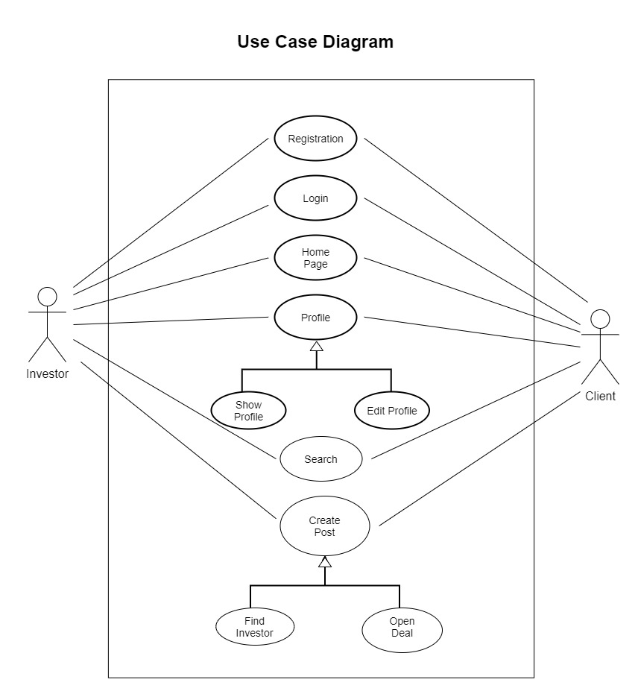

Fig 1: Use-case Diagram

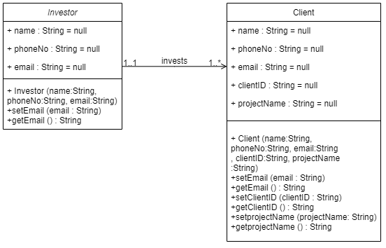

Fig 2: Class Diagram

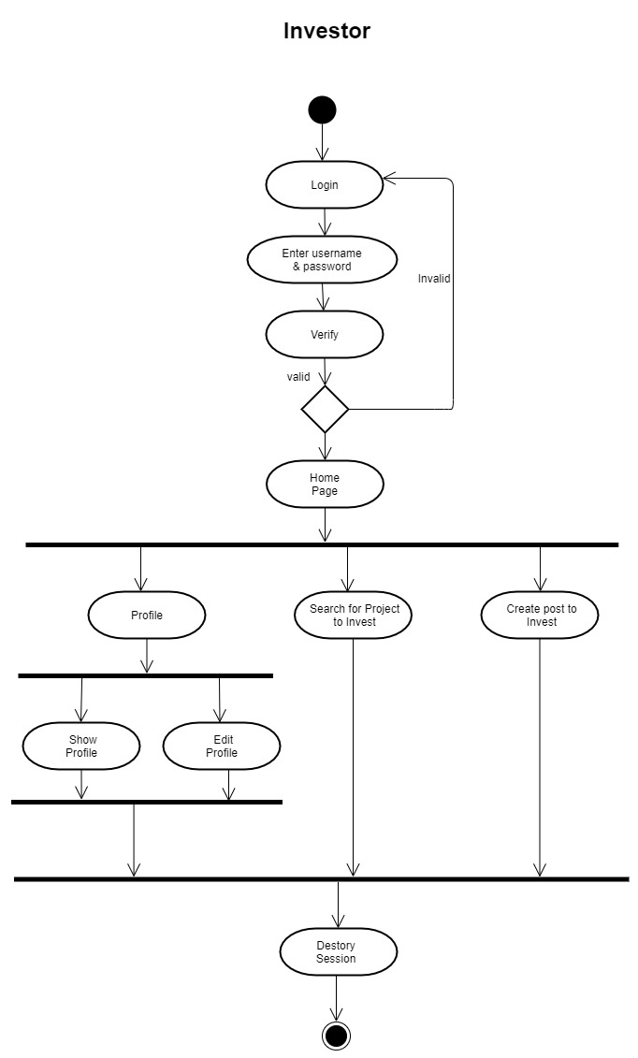

Fig 3: Activity Diagram

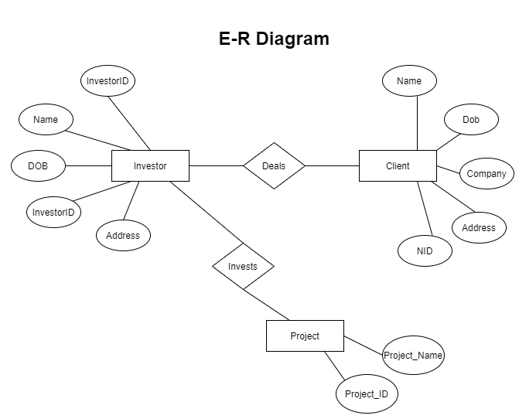

Fig 4: E-R Diagram

## Data Dictionary

|  |  |  |  |  |
| --- | --- | --- | --- | --- |
| **Entity** | **Attribute** | **Type/size** | **Validation** | **Key** |
| Investor | ID | Number (8) | 10009762-33333329 | Primary |
| Name | Text (15) | Required |
| Username | Text (8) | Required |
| Email | Text (30) | Valid Email |
| Phone | Number (13) | Required |
| DOB | Date (8) | Valid Date |
| TradeLicense | Number (17) | 4437-5433-1726-61 |
| Client | ID | Number (8) | 27688910-11111127 | Primary |
| Name | Text (15) | Required |
| Username | Text (8) | Required |
| Email | Text (30) | Valid Email |
| Phone | Number (13) | Required |
| DOB | Date (8) | Valid Date |

## UI/UX Design Specification

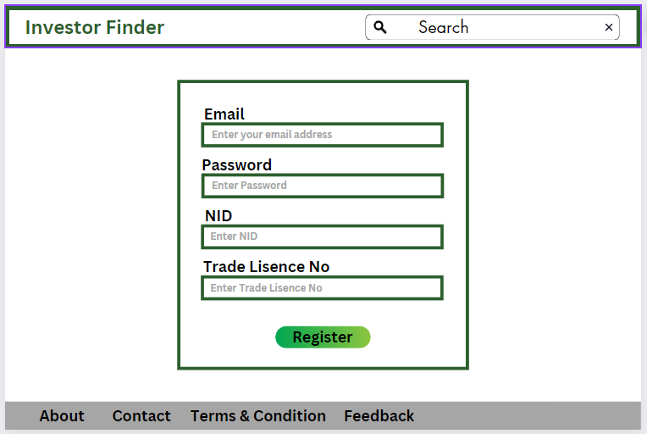

Fig 5: User Registration

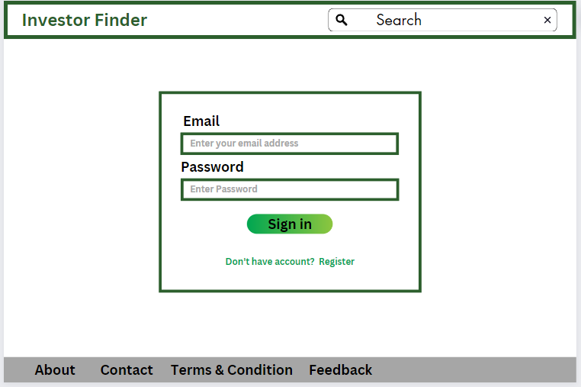

Fig 6: User Sign-In

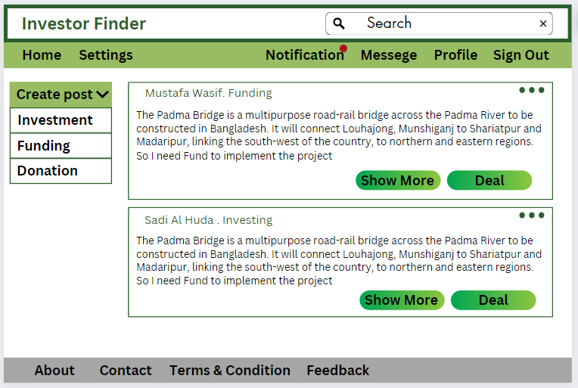

Fig 7: Home

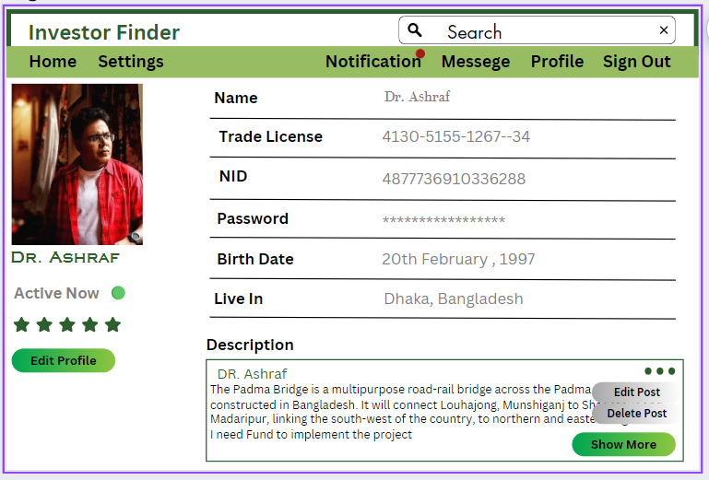

Fig 8: Profile (User’s View)

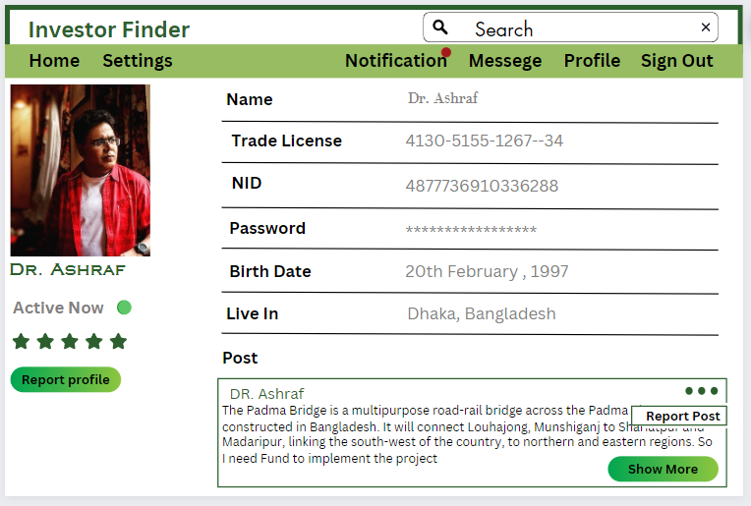

Fig 9: Profile (Visitor’s View)

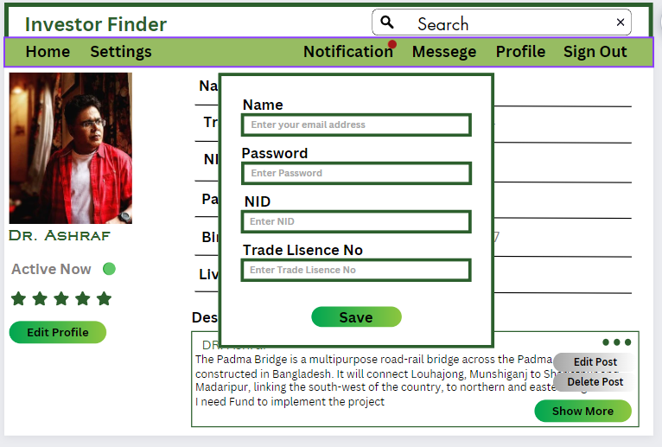

Fig 10: Edit Profile

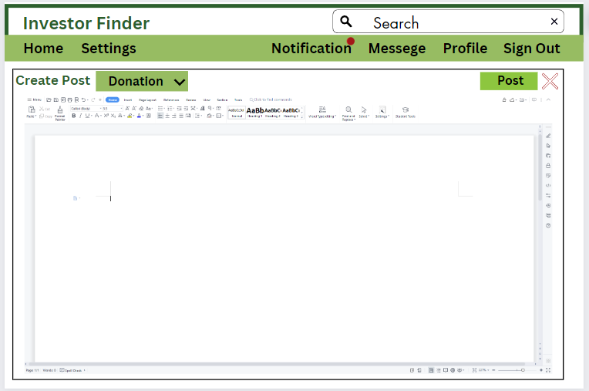

Fig 11: Create Post

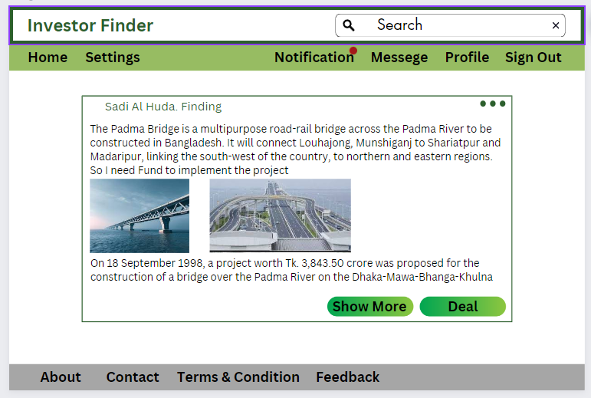

Fig 12: Post Details

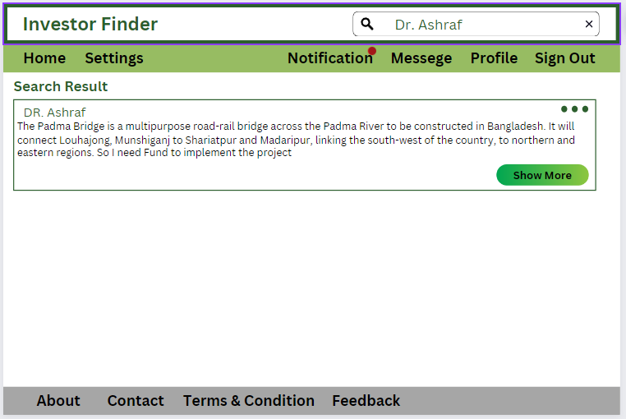

Fig 13: Search Profile

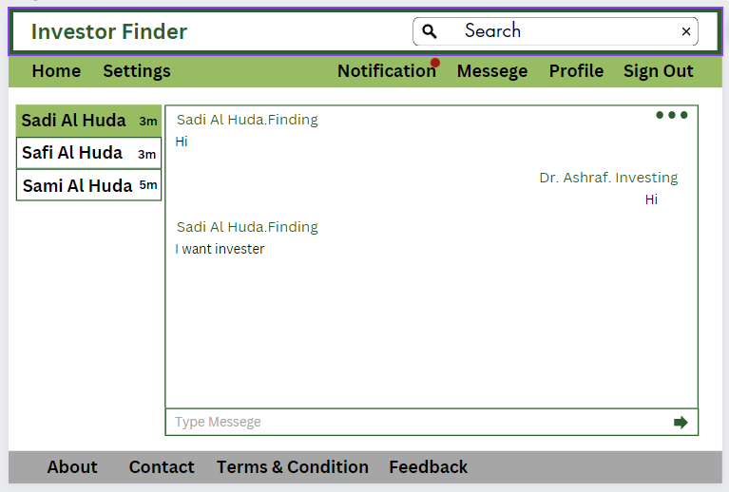

Fig 14: Investor Dealing

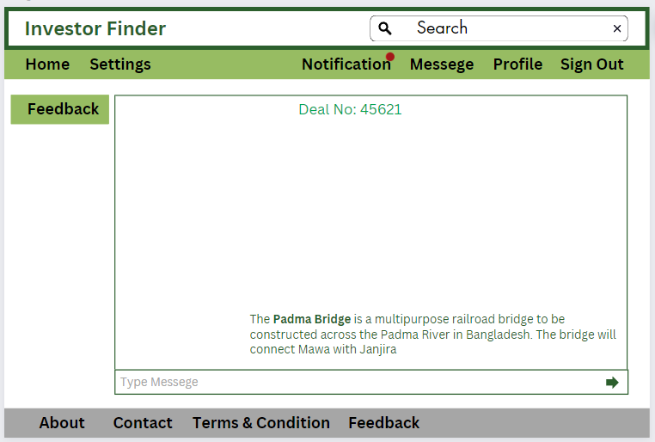

Fig 15: Feedback